**Measurement 3: Cranial Capacity**

Introduction: The brain is housed inside the cranium. The interior volume of the cranium is called the cranial capacity. This module facilitates the measurement of the cranial capacity. Homo sapiens, cranial capacity varies widely from 1200cc (cubic centimeters) to 2000cc with each level of intelligence on either end.

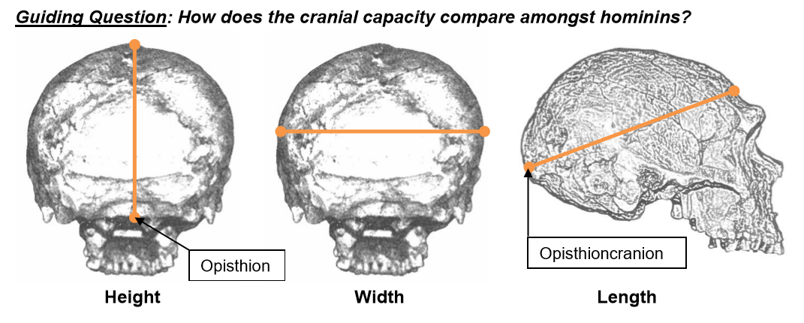

Measure: To estimate the cranial capacity of each skull, using the caliper measure the space of the part of the cranium that houses the brain. Calculating the cranial capacity provides a rough numerical value for the size of the brain.

* Measure the maximum length by placing one end of a caliper on the most forward projecting point of the forehead (above the brow ridge) and the other end on the most posterior point at the back of the skull, i.e. the opisthiocranium.
* The maximum width is determined with the calipers on the sides (temples) of the skull at the widest point (above the zygomatic process).
* The maximum height is measured by holding one arm of the caliper on the underside flush with the foramen magnum and the other arm at the top most point of the skull.
* Multiply these three measures and then multiply by 0.5236

(L x W x H) * 0.5236

*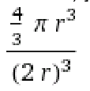Where the figure 0.5236 comes from:*

*We are determining the volume of a sphere within a cube. First, we use the spherical volume [4/3 pi (1/2 length)3] and the cubic volume [cubic length (2 x radius)3], and then divide the two formulas as follows:*

*Thus, the ratio of sphere volume to cube volume is 0.5236.*

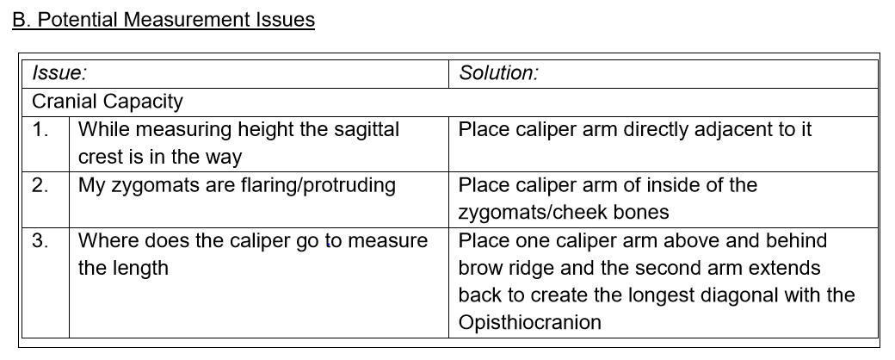

C. Analyze: Examine the estimated cranial capacities you calculated.

Q. Which species had the largest cranial capacity?

A. Homo Neanderthalensis had the largest brain. Although it should be noted where his brain is larger compared to Homo sapiens, he has much less of a forehead, and a wider cranium towards the back, in a similar fashion as Homo heidelbergensis.

Q. Of what is cranial capacity a good indicator, at least across genus? A. The larger brain size of Homo has a bigger potential for higher brain functions, increased tool use, and group complexity. Homo habilis – as the handy man – overcame his gracile stature to compete and outlive his competitors, the robust Australopithicines.